
EU2015
Information Provision

Contents

Title |  |  | Page
1 |  | Executive Summary | 2
2 |  | Background Information | 2
 | 2.1 | National Grid Information Provision | 2
 | 2.2 | New EU Obligations (2015) | 2
3 |  | MIPI - Proposed Solution | 4
 | 3.1 | Overview | 4
 | 3.2 | Change Schedule | 4
 | 3.3 | Data Item Explorer | 4
 | 3.4 | Report Explorer | 5
 | 3.5 | API Service | 6
4 |  | MIPI - Alternative Solution | 7
 | 4.1 | Overview | 7
 | 4.2 | Implementation of Alternative Solution | 7
 | 4.3 | Data Item Explorer | 7
 | 4.4 | Report Explorer | 8
 | 4.5 | API Data Retrieval | 8
5 |  | GMRS Impact | 8
 | 5.1 | GMRS Gas Day Timings | 8
 | 5.2 | GMRS Bacton ASEP Split | 9
6 |  | Contacts and Support | 9
Appendix |  | Appendix | 10
 | 1 | EU2015 MIPI Timeline | 10
 | 2 | New and Re-named Data Item List | 10
 | 3 | EU2015 MIPI Timeline – Alternative Solution | 10
 | 4 | Alternative Solution: Using Report Explorer’ | 10

1. Executive Summary

The purpose of this document is to;
- Provide an overview of National Grid’s information provision service.
- Provide information about the EU2015 project, which will ensure compliance to new EU regulations, referred to as the Third Energy Package.
- Introduce both the Market Information Provision Initiative (MIPI) ‘Proposed’ and ‘Alternative’ information provision approaches and their associated customer journeys.
- Describe changes to the Gas Market Reporting System (GMRS).
- Provide contact details for any queries.

-----------------------------------------------------------------------------------------------------------------------------------------

2. Background Information

2.1. National Grid Information Provision

National Grid Gas Transmission has a range of responsibilities associated with operating the network and with facilitating the effective and efficient operation of the GB gas market. One of the key responsibilities is the facilitation of the gas market through provision of timely and accurate data and information. The data provided allows market participants to make informed commercial decisions, thus ensuring that users can act effectively and reduce market uncertainty.

This information is published through the Market Information Provision Initiative (MIPI) and Gas Market Reporting System (GMRS) platforms. The MIPI application provides a wealth of gas market information whereas the GMRS application purely provides instantaneous entry data. Users can obtain the information either by accessing the website directly or through facilitation of the Automatic Programmable Interface (API) service. National Grid is obligated under Uniform Network Code and European Code requirements to publish this data. OFGEM also incentivises National Grid to ensure the availability of our information provision pages and the timely publication of data items.

This data is valued by shippers, trade press and the wholesale gas energy market, and has led to increasing demands on the platforms. The high usage of MIPI and GMRS has resulted in some recent issues with performance and availability.

2.2. New EU Obligations (2015)

The European Union (EU) legislation on European gas and electricity markets referred to as the Third Energy Package was introduced by the European Parliament and the Council of the European Union in 2009, and came into law on 3rd March 2011. The aim of this legislation was to create a harmonised European internal energy market.

The Third Energy Package consists of two EU Directives and three EU Regulations;
- Directive 2009/72/EC - concerning common rules for the internal market in electricity
- Directive 2009/73/EC - concerning common rules for the internal market in gas
- Regulation (EC) No 713/2009 - on the establishment of the Agency for the Cooperation of Energy Regulators ACER
- Regulation (EC) No 714/2009 - on conditions for access to the network for cross-border exchange of electricity
- Regulation (EC) No 715/2009 - on conditions for access to the natural gas transmission networks

The legislation included the obligation to create the European Network of Transmission System Operators for Gas (ENTSOG) and the Agency for the Cooperation of Energy Regulators (ACER). One of the key objectives of ENTSOG stipulated in the legislation is to prepare EU Network Codes to enable progress towards a competitive and efficient energy market in gas. After these codes have been reviewed and approved by ACER they are then written into EU Law, ensuring the codes become binding on Member States of the EU.

Each EU Network Code (Congestion Management Principles (CMP), Capacity Allocation Mechanism (CAM), Balancing, Interoperability and Tariffs etc.) contains (or will contain) requirements for translation into the GB regime. It is for the TSOs to develop what the logical grouping of implementation phases should be in order to achieve compliance. Rather than implement on a code by code basis, National Grid believes that compliance can be most effectively achieved through implementation phases. Each phase will require changes to the UNC, relevant Gas Transporter Licences and associated industry processes. Each Phase will also require changes to industry systems and will have its own IS release plan. The new European legal and regulatory obligations are being introduced in four phases between 2013 and 2017.

The ‘National Grid EU Project Phase 2’ (referenced to as ‘EU2015’) will deliver on obligations related to CMP, CAM, Balancing and Interoperability Network Codes. These obligations become effective from 1st October 2015, and 1st November 2015.

One of the key requirements relates to the commercial splitting of the Bacton Aggregated System Entry Point (ASEP). The existing ASEP will be divided into two components that relate to the following sub-terminals from 1st November 2015;

Bacton ASEP Name | Related Bacton Sub-Terminals
Bacton Interconnector Points (Bacton IPs) | Bacton BBL and Bacton I(UK)
Bacton UK Continental Shelf (Bacton UKCS) | Bacton Perenco, Bacton Shell, Bacton Seal and  Bacton Tullow

Data and reports in the MIPI and GMRS applications will be amended to reflect this commercial change. Data items sent via the MIPI application directly to the ENTSOG platform will also be amended as appropriate.

-----------------------------------------------------------------------------------------------------------------------------------------

3. MIPI - Proposed Solution

3.1. Overview

In compliance with the CMP, CAM, Balancing and Interoperability Network Codes, a number of changes will be made to the MIPI application. The implementation of this ‘Proposed’ solution will enable users to access all data in the usual way;
- Data can be downloaded through the Data Item Explorer function
- Pre-defined reports in Report Explorer will contain the new / revised data items
- Data can be retrieved through the API service.

3.2. Change Schedule

Please refer to Appendix 1: EU2015 MIPI Timeline. This document provides the proposed schedule for implementing the required system changes.

3.3. Data Item Explorer

There will be a number of new and re-named data items visible in Data Item Explorer. These are captured in Appendix 2: New and Re-named Data Item List.

Further detail on each of the tabs names in the spreadsheet is provided below;
- Step 1: Implementation of 273 new data items to be incorporated into existing reports. This covers scenarios such as the Bacton ASEP splitting into the two new ASEPs (see section 2.2). It is worth noting that if a user requests data that includes before and post 1st November changes, all three data items will need to be selected (Bacton, Bacton IPs and Bacton UKCS) in order to retrieve the full data set. The data items will be visible on 2nd July 2015 but publication of this data will not commence until 1st November 2015.
- Step 2: Implementation of 265 new data items associated with completely new reports. The data items will be visible on 15th July 2015 but publication of this data will not commence until 1st November 2015.
- Step 3: Existing data items already in the MIPI application will be permanently re-named. This covers scenarios such as revised time periods to reflect the new Gas Day e.g. instead of 06:00-12:00, the new data items reflects the ‘first 6 hours of the Gas Day’ and the re-naming of ‘off-peak’ capacity items to ‘interruptible’ for the Interconnection Points.
- Bacton Split: This provides a list of the existing ‘Bacton ASEP’ data items and their new ‘Bacton IPs’ and ‘Bacton UKCS’ equivalents. The new Bacton ASEP data items will be implemented in Step 1’, which is scheduled for 2nd July 2015.

Note: Not all of the data items listed are available in Data Item Explorer; some by-pass the MIPI application and are exclusively published to the ENTSOG platform. This is because these data items are related directly to European Compliance rather than the GB Market.

There is also a further change to the format of some of the capacity price data. The price format will be changed from NUMBER (6,4) to NUMBER (10.8). For example, Number(6,4) = 0.1234 to Number(10,8) = 0.12345678.

3.4. Report Explorer

There will be 6 completely NEW reports in Report Explorer:

 | - Report Name | Description
1 | Monthly IP Entry Cap Reserve Price-CMP | - Entry capacity Cleared, Reserve and Premium price for  - the IP Monthly Auction.
2 | - No LT Firm Entry Capacity offered-CMP | Details when no Long Term Entry capacity has been  offered via the CMP mechanism.
3 | - Total Entry Capacity Made Available-CMP | The total amount of Entry capacity made available  via the CMP mechanism.
4 | - Monthly IP Exit Cap Reserve Price-CMP | - Exit capacity Cleared, Reserve and Premium price for  the IP Monthly Auction.
5 | - No LT Firm Exit Capacity offered-CMP | Details when no Long Term Exit capacity has been  offered via the CMP mechanism.
6 | - Total Exit Capacity Made Available-CMP | The total amount of Exit capacity made available  via the CMP mechanism.

The data items contained within these reports are detailed in the spreadsheet ‘Appendix 2: New and Re-named Data Item List’ on the ‘Step 2’ tab.

11 EXISITING reports will contain new data items:

The impacted reports and reason for these new data items are captured in the table below. The data items contained within these reports are detailed in the spreadsheet ‘Appendix 2: New and Re-named Data Item List’ on the ‘Step 1’ tab.

Report Name | Reason for New Data Items
Report Name | Bacton ASEP  Split | Gas Day  Change | New Capacity Product
- Daily Auction Summary | 
- Exit Capacity Availability |  |  | 
- Long Term Capacity Auction |  |  | 
- Capacity Availability Report (NORD07) |  |  | 
- Future Entry Capacity Traded (NORD03a) | 
- Future Entry Capacity Traded - Capacity (NORD03b) | 
- Future Entry Capacity Traded - Transactions (NORD03c) | 
- Within Day Entry Capacity Traded - Transactions (NORD03d) | 
- Within Day Entry Capacity Traded - Capacity (NORD03e) | 
- Aggregated Day Ahead Nominations |  | 
- Daily Operation Information(NORD01c) |  | 

All of the data above is impacted by the commercial splitting of the Bacton ASEP. If the user selects a report pre-1st November, the report will present the ‘Bacton’ ASEP data. If the user selects a report post-1st November, the report will present the two new Bacton ASEPs called ‘Bacton IPs’ and ‘Bacton UKCS’. For the avoidance of doubt, we will not be amending the data prior to the 1st November 2015. All data prior to the 1st November will be retained against the original ASEP description.

3.5. API Service

All of the new and re-named data items referred to above will be available to retrieve through the API Service; the ‘API Data Item List’ on the Supporting Information page will be updated accordingly. The user must make changes to their API request in order to obtain the full report. This update will not take place automatically. The frequency of publication for these timestamps will be documented in the API Data Item list; Users are reminded to be vigilant when writing their test scripts to avoid polling the data at unwarranted frequencies. Please refer to the ‘API Guidance’ document on the Supporting Information page for more information about our fair usage policy.

There are two key dates that API users need to be prepared for;

Date | Action Required
5th September 2015 | Requests need to be amended to pick up the re-named data items. These are  listed in ‘Appendix 2: New and Re-named Data Item List’ (Step 3)
1st November 2015 | Requests need to be amended to pick up all completely new data items. These  are all listed in Appendix 2: New and Re-named Data Item List’ (Step 1 & Step 2).

-----------------------------------------------------------------------------------------------------------------------------------------

4. MIPI ‘Alternative’ Solution

4.1. Overview

As alluded to in the information above, the MIPI and GMRS applications are extensively used and host a wealth of data (currently ~13,500+ data items); the volume of requests for this data is already impacting performance. This poses a constraint when seeking to add any new data to the applications.

Should the performance of the applications deteriorate to an unsatisfactory level, an ‘Alternative’ solution has been designed to meet minimum compliance requirements of European Law, which is mandatory, whilst maintaining performance and availability of MIPI and GMRS for all users.

The implementation of this ‘Alternative’ solution would only happen once all other options have been exhausted, as this does pose restrictions on the way that users obtain data from the MIPI application. There are two constraints associated with the ‘Alternative’ solution;
- New data items will not be available to select through Data Item Explorer
- New data items will not be available to retrieve through the API service

Instead, the data will only be available to download through the pre-defined static reports in the Report Explorer application.

Once the ‘Alternative’ solution has been implemented, it will not be possible to revert to the original ‘Proposed’ solution; this solution will remain operational until the MIPI replacement service is delivered in 2016.

4.2. Implementation of ‘Alternative’ Solution

A decision to implement the ‘Alternative’ solution could be taken at any of the stages described below;
- Step 1: After delivery of the new and re-named data items (July - September 2015)
- Step 2: After the new Gas Day timing changes become effective (1st October 2015)
- Step 3: After the new CAM/CMP regime becomes effective (1st November 2015)

Implementing the alternative solution at any of these points will result in different outcomes; these are described in Appendix 3: EU2015 MIPI Timeline – Alternative Solution

4.3. Data Item Explorer

Once the ‘Alternative’ solution has been implemented, none of the completely new data items will be visible in the Data Item Explorer application, aside from The Future Entry Capacity Traded (NORD03a) report. All data retrieval must be via the Report Explorer for these new data items. The data items that have been re-named (Step 3) will remain available to select from Data Item Explorer.

4.4 Report Explorer

If the ‘Alternative’ solution is implemented, all reports and new data will continue to be available in the Report Explorer application. For those reports that contain new data items associated with the EU2015 project, there will be a new function to download this data. Please refer to the instructions in ‘Appendix 4: Alternative Solution: Using Report Explorer’ for guidance on how to obtain this data.

Note: If the ‘Alternative’ solution is implemented, the user will need to use Data Item Explorer to obtain data before this point. After the ‘Alternative’ solution is implemented, the user will need to use the new Report Explorer download option. If a user wants to download a report that crosses the pre and post alternative solution, there will be two steps in involved to create the work.

Download data via Data Item Explorer
Download data via Report Explorer
Alternative Implemented

There are some existing reports where new data items will be added. This will result in a combined approach of retrieving historic data through the existing Data Item Explorer route and the new function in Report Explorer.
Data Item Explorer – ‘Old’ data
e.g. Bacton ASEP
Report containing ‘old’ and ‘new’ data
Report Explorer – ‘New’ data
e.g. Bacton IPs and Bacton UKCS

4.5. API Data Retrieval

The API service will be available if the ‘Alternative’ solution is implemented. However, there will not be an option to retrieve any of the new data items via the API service.

-----------------------------------------------------------------------------------------------------------------------------------------

5. GMRS Impact

Changes are also required to the GMRS application to align with the new Gas Day timings and the commercial split of the Bacton ASEP.

The possible implementation of the ‘Alternative’ solution has NO impact on the GMRS application.

5.1. GMRS Gas Day Timings

The Gas Day labels on the GMRS page (Instantaneous Flows, Entry Zone Graphs and User Defined Download) will be reconfigured to reflect the new Gas Day timings of 05:00-04:59.

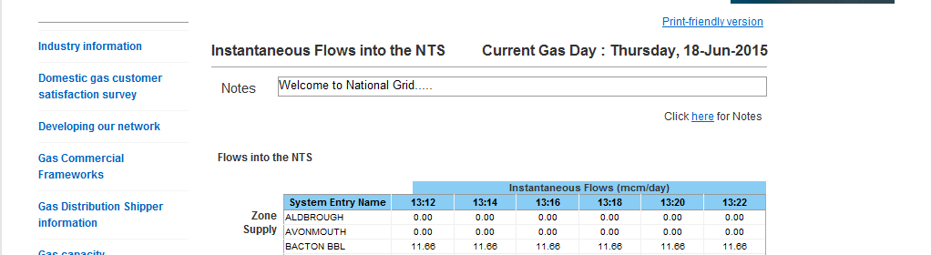

5.2. GMRS Bacton ASEP Split

Instantaneous Flows data is available at entry point level but also presented as aggregated points (ASEPs).The current Bacton ASEP will be presented as two ASEPS; Bacton IPs and Bacton UKCS post 1st November 2015.

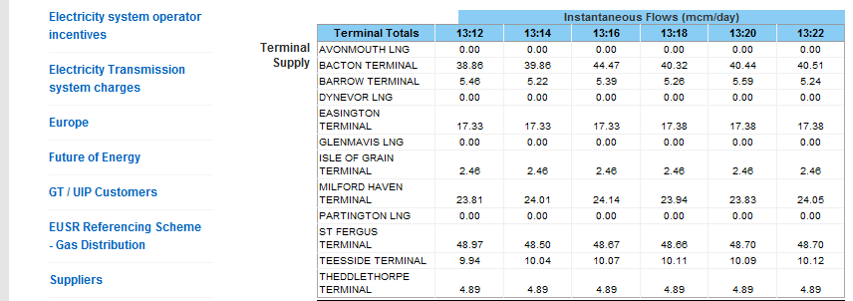

In the User Defined Download application, all three data points will be available to select from the list; Bacton, Bacton IPs and Bacton UKCS. This will ensure that any historical data requests for Gas Days before and after the commercial splitting of the Bacton ASEP will be possible.

API Service:
If any user obtains this data via the API (automatic programmable interface) service, they will need to potentially update their request to retrieve the new data items.

The original Bacton ASEP point will be re-named to ‘Bacton Terminal (Prior to 1st November 2015)’.

-----------------------------------------------------------------------------------------------------------------------------------------

6. Contacts and Support

If you have any further queries, please do not hesitate to contact a member of the Operational Compliance team.

Contact | Phone | Email
Operational Compliance Team | 01926 65 6474 | sysop.centre.reporting@nationalgrid.com

-----------------------------------------------------------------------------------------------------------------------------------------

Appendix

Appendix 1

EU2015 MIPI Timeline

Appendix 2

New and Re-named Data Item List

Appendix 3

EU2015 MIPI Timeline
- Alternative Solution

Appendix 4

Alternative Solution: Using Report Explorer

Obtaining data from Report Explorer once the ‘Alternative’ solution has been implemented.
- Open the relevant report in Report Explorer
- Click on the ‘Download EU2015 Data’ link
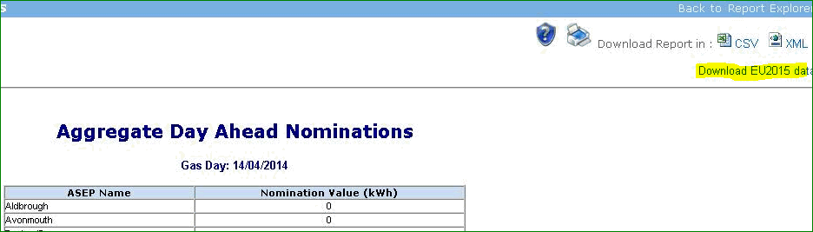
- Select the report from the drop-down list
- Select the Gas Day
- Choose to download to CSV or XML

